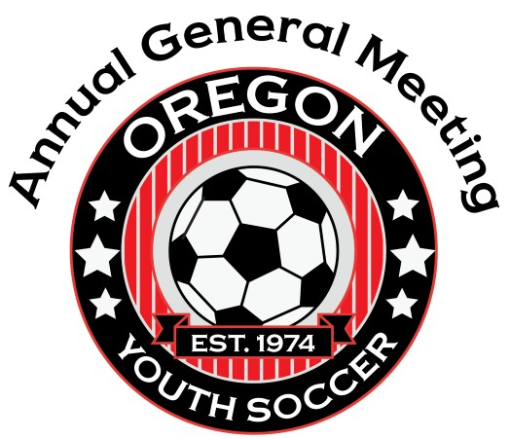
Together Everyone Achieves More
2022 Annual General Meeting Workshop Schedule
Spirit Mountain Casino Events Center
Friday, January 28th
Friday Evening Social 6pm - 9pm Molalla A&B

Saturday, January 29th
AGM Registration Desk 7:30 am – 5:30 pm Foyer

Registration Workshop - Desia Bramel & Stack 8:00 am - 11:30 am Molalla B

Recreational Town Hall - Nelson Larson 8:00 am – 9:00 am Molalla A

Mojo Coaching App Presentation 9:00 am – 9:30am Molalla A

Department of Justice - Susan Boyer 10:00 am - 12:00 pm Molalla A

Building Trust in the Club-Coach-Parent Relationship - Skye Eddy 9:00 am - 11:30 am Kalapuya A

Referee Education (Registration Required) Alex Chilowicz 9:00 am - 5:00 pm Kalapuya B

Lunch - on your own 12:00 am - 1:30 pm

Registration individual training - Desia Bramel & Stack 1:00 pm - 5:00 pm Chasta A/B
Registration Required

Education & Engaging Parents to Improve Club Culture - Skye Eddy 1:00 pm - 2:30 pm Kalapuya A

Suicide Prevention Training (Registration Required - Max 35) - 1:30 pm - 3:00 pm Molalla B
Polk County School Based Mental Health Program

Perspective from the Referees - David Grbavac, Manager of Referee Dev. 3:00 pm - 4:00 pm Molalla B

Presidents Meeting - Steve Baker 4:00 pm - 5:00 pm Molalla B

Annual Awards Gala & (Tickets Required) Silent Auction 6:30 pm - 10:00 pm Event Center A

Sunday, January 30th
Annual Business Meeting – OYSA Board Meeting Follows 9:00 am - 12:00 pm Molalla A & B

