Adding Board Members

- It is easiest if you select Classic View to enter board members.
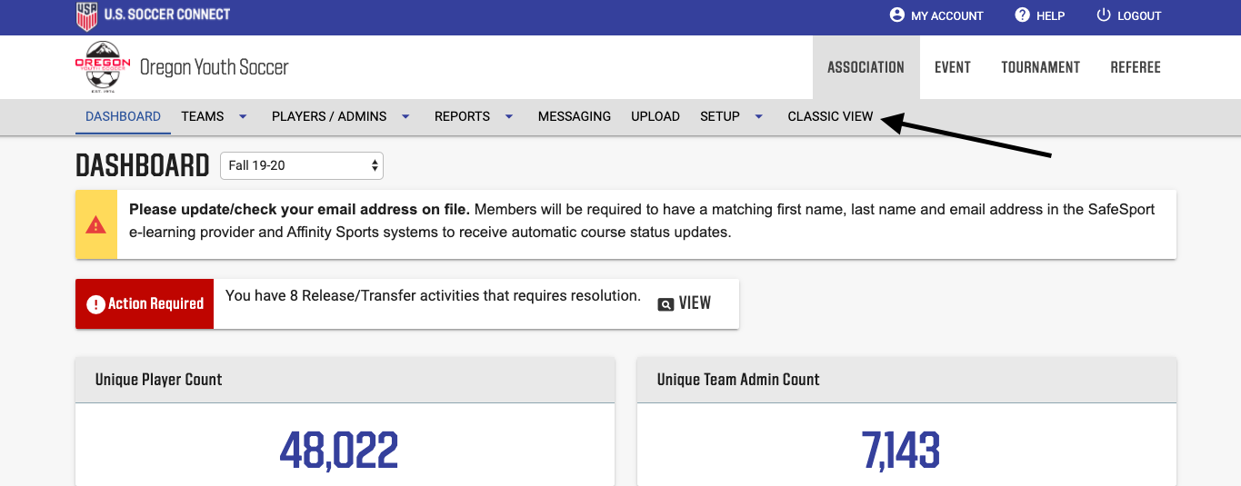
- Then, select League on the left-side and enter your club name. This will bring up the screen below for your club. DO NOT ENTER BOARD MEMBERS AT YOUR CLUB LEVEL.
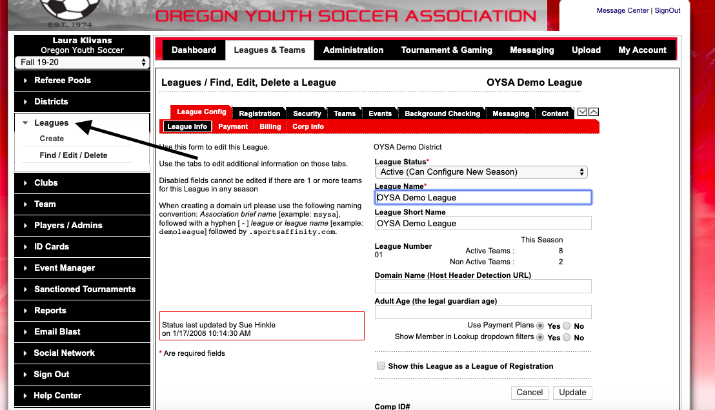
- Then, select the Security Tab. This will show you the current board members you have listed in the Connect Platform and can add/remove board members.

- To add new members, they must have an approved background check for the current seasonal year. Select Find/Add Admin with Approved Risk Status and search for your board member by name. Once you find the person, you can select User Type and Level of Access. User Type is the board position they hold within the club and Level of Access is what they can see/do in Connect Platform. League Board Member will only be able to view data in Affinity and League Registrar will be able to view and make changes to data.

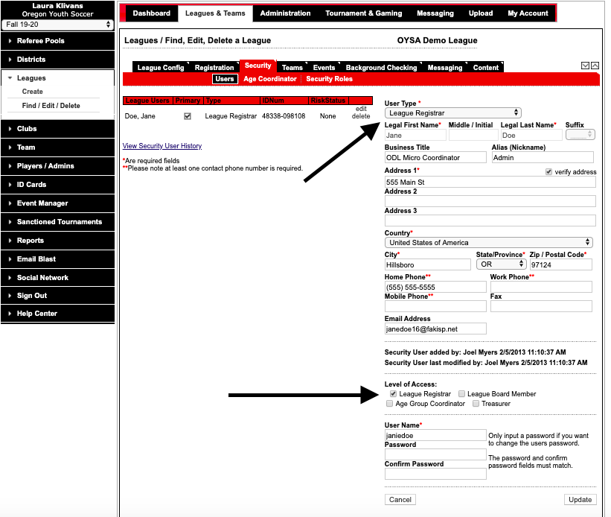
- Once information is completed, select save. You can change board members permission at any time.
- Type of User Types and Level of Access suggested:
  - Registrar = League Registrar/League Registrar
  - Billing Contact = Billing Contact Info/League Board Member
  - Club President = League Level Club President/League Board Member
  - DOC = League Level Head Coach/League Board Member
  - DO NOT USE LEAGUE LEVEL CLUB REGISTRAR
  - For all other positions = User/League Board Member
- If you have a board member that has either been removed or has left their position, immediately delete their record from the Security tab so that they do not have access to the club’s information. This does not delete their parent or coach record.

