Creating and Saving Reports
Connect users have the ability to quickly save reports and bookmark the reports they use most often with the Save Report feature.

Save Report
- To save a report, choose Reports and then choose the report category in which you wish to locate and save a report from the main navigation. You may also save reports from other report areas within the platform including tournaments and events.
- Select any filters and/or enter any report criteria.
- Select the Report Type (if applicable and optional).
- Choose Save Report.
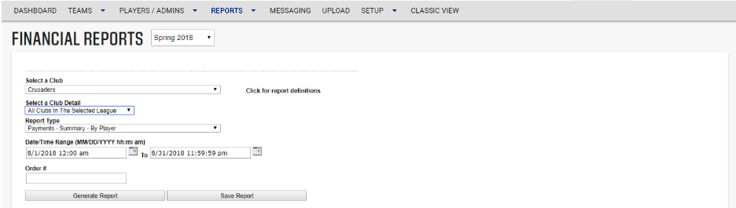
- A pop-up window opens, asking you to enter the name of the report you are saving and choose OK.
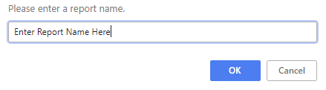
- The pop-up window refreshes and indicates that the report has been saved successfully. Choose OK to close the pop-up window.
NOTE: Report names must be unique. If you attempt to name a report a name already in use the system will alert you and ask if you wish to overwrite the current report with that name.
- You will now be able to access your saved reports by choosing Reports and My Reports from the main navigation.

My Reports
- To access your saved reports, choose Reports and My Reports from the main navigation.
- A list of your saved reports will display.
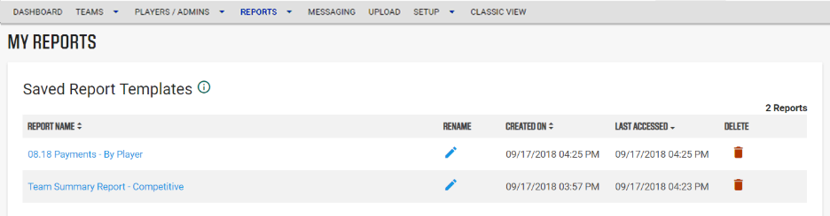
- You may sort your list of reports by Report Name, Created On date, or Last Accessed Date by choosing the up/down arrow next to the name in the header row.
- Rename allows you to change the name of the report.
- Delete removes this report from your saved reports.
- To run a report, click on the name of the report in the list of your reports. Once clicked, the report selection criteria page displays. You can choose to generate the report as saved or change the filters and/or other report criteria before running the report.
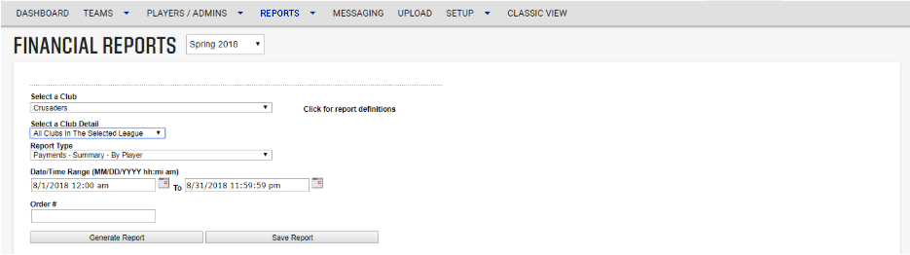
- Choose Generate Report when ready to run your report.
NOTE: Be sure to check your season in the season dropdown to ensure you are running the desired report.

Billing Report

The Activated Billing Summary Report by Team is the report we will be using to create your bills.
- Select Activated Billing Summary Report from Billing drop down menu.
- Enter your date range from the last pull dates.
- You will have options of New, Returning, and All players to select.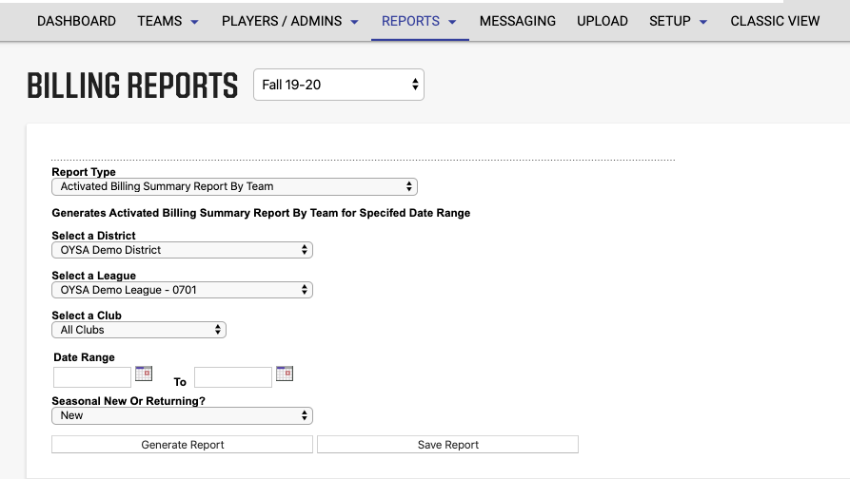
- Once the report has been generated, you can export it as a PDF to print/save.

