Online Registration Set Up Checklist

To open up your seasonal year registration in Soccer Connect (Affinity), you need to configure your registration at both the League and Club levels. Below are screen shots to assist you with this process. Only clubs that fully only use Soccer Connect (Affinity) will need to set up fees at the club level. All other clubs just need to check the appropriate boxes for the type of registrations that their club will do – coach and/or players.

Clubs are required to only use the Fall __-__ seasonal years. Clubs should only use the Spring __ seasonal year if they are only using the Affinity registration system and only if they are capturing new fees for Spring. Otherwise, always stay in the Fall season as it covers the entire seasonal year.

Opening up your New Seasonal Year

- Click on the League tab.
- Click on the Search button and your club should show up.
- When your club shows up in the listing, click on the League Name.
- Go to the Registration tab. This screen will show you the available seasonal years for you to open as well as old seasonal years. The below screen shot shows that the club has open the Fall 19-20 seasonal year.

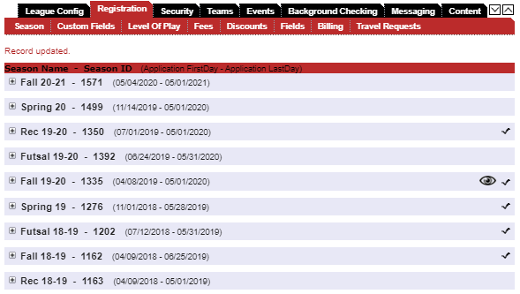

- Click on the seasonal year to open. The below screen shot shows that this club has Competitive U10-U20 and Recreational U5-U20 open for both coaches and players. We suggest that if your club services recreational players ages U9 to U14, that you typically open up an age group 1 year young and 1 year older. If your club only wanted to have open registration for coaches and not players, you could simply uncheck the players box and it would stop player registrations. You can also see by the below screen that none of the boxes are checked for Developmental players. You can open or close any of these as you wish. Checking the box for Show On Public Registration is what now opens the season for registration. You could set up your entire seasonal and just not check that box until you are ready to open. You can also set dates to activate and deactivate registration. This comes in handy if say your registrar is going to be out of town during the times that registration opens and closes. The system will do it for you.
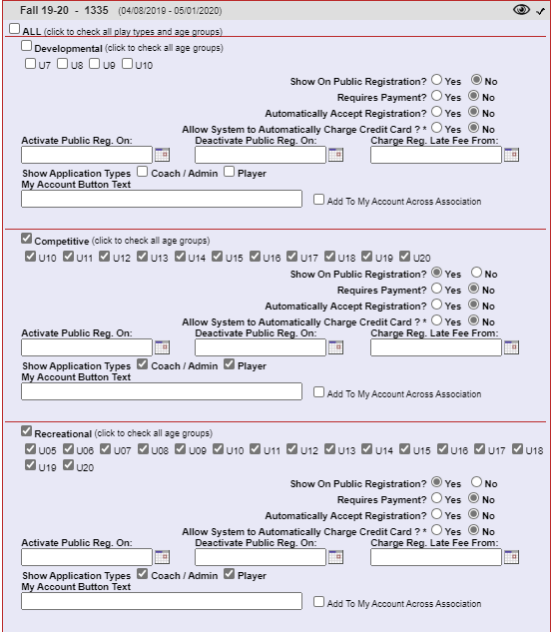

- This is all that you need to do at the League level.
- Now lets go to the Club level. We can do this by either clicking on the Club tab on the left hand side of our screen, or clicking the down arrow at the top of this page.

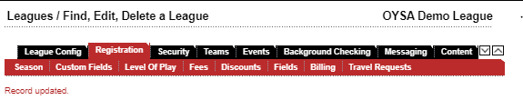

- At the Club level we are going to do the same that we did at the League level. We are going to check all play levels and ages that were checked at the League level. At the Club level (and only if you are only using Affinity for your registration) will you set up your club fees, ELA’s, custom fields, etc. Please call OYSA to set up an appointment to go through this with you.

Find your Club’s Link to the Coaches Background Check
- Go to the Club/Club Config tab
- You will see your domain name in the 4th box down.
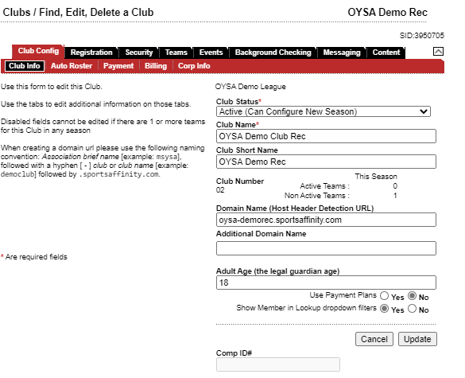
- Copy that link and go to your web brouser and paste this information.
- You will see your welcome page. Unless you use this welcome page, we suggest just clicking on the Registration tab at the top right of your screen.

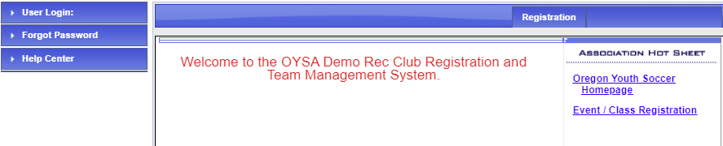

- This brings you to your club’s direct registration page for coaches/admin background checks. We suggest just using this link to send directly to your coaches and bypassing the welcome page.

