Emailing Players and Admins
The State Platform allows Registrars to email player’s parents and admins from the player, administrator and parent lookup functions. Additionally, emails can be sent from the Team Roster screens. When you perform a lookup for a particular subset of your members, you will notice an icon in the shape of an envelope at the top far left of the search results and a column under this icon next to each name. This is the icon for sending emails.

Email by Team
- Choose Teams and Team Lookup from the main navigation.
- Select any filters and choose Search.
- From the Search Results, click on the Team Name to view the Team Details.
- Choose the Team Roster tab.
- Click the top envelope icon to select all players or all administrators for the team or check only the individuals you wish to email.
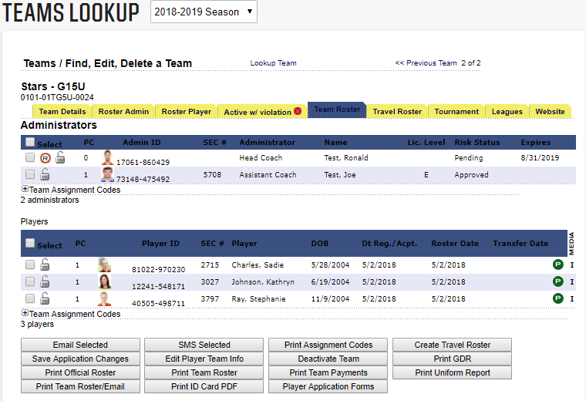
- Choose the Email Selected button.
- You will be taken to a content editor screen where you can compose your email.

- Enter the From Name, From Email address, any cc email addresses, a subject, add any attachments and your message in the body field.
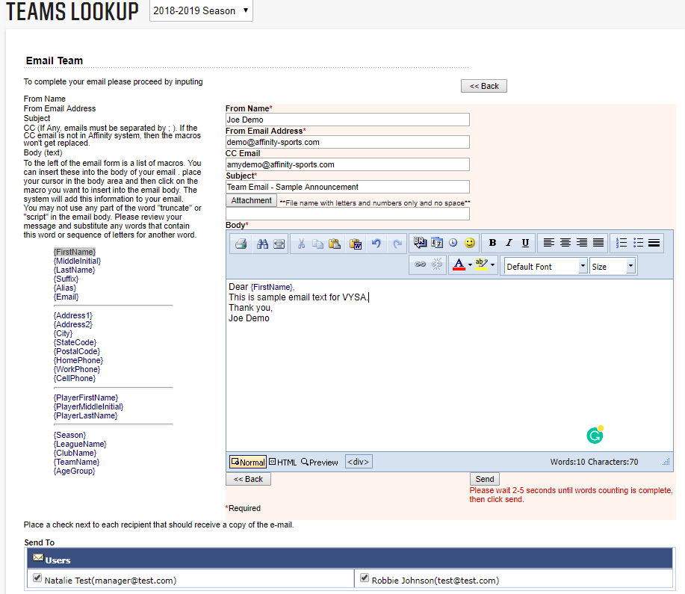
- Once your email is drafted, you may see the list of recipients below that are scheduled to
receive the email. You may add or remove them by checking or unchecking the box next
to their name.
- To send your message, click Send below the message content editor.
- If you have more than 25 recipients with valid email addresses, the system will show a message at the bottom of the screen that indicate that you have selected too many users to display here:
- If less than 25 recipients, the system will show all recipients and their email address with the option to uncheck recipients.

Email Players and Administrators from Player or Admin Lookup
- Choose Players/Admin and Player Lookup or Admin Lookup from the main navigation.
- Select the filters you would like to use and choose Search.
- A list of players or admins based on your criteria displays.
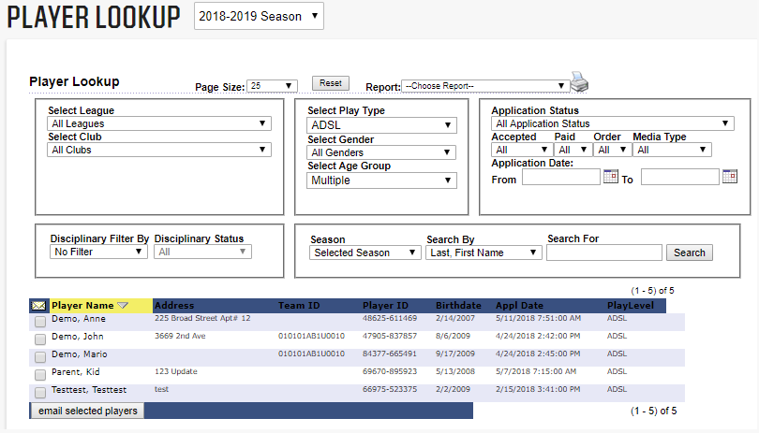
- Click the top envelope icon to select all players or all administrators or check only the individuals you wish to email.
- Choose the Email Selected Players or Admin button at the bottom of the search results.
- You will be taken to a content editor screen where you can compose your email.
- Enter the From Name, From Email address, any cc email addresses, a subject, add any attachments and your message in the body field.
- Once your email is drafted, you may see the list of recipients below that are scheduled to
receive the email. You may add or remove them by checking or unchecking the box next
to their name.
- To send your message, click Send below the message content editor.

Email Content Editor
Once you have selected the persons you wish to email you will be taken to an email content editor. This editor will allow the user to create a basic email with various font size, type and color and some other basic features. The user is also able to cc additional individuals and upload an attachment.

