Game Scoring

Only a rostered adult member of the team with an Connect Platform login can access the Status Update to enter scores.

- After your match has been played, go to Tournament & Schedules Apps – Schedules/Game Scoring tab.
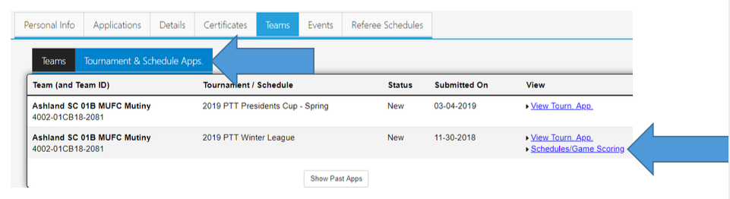
- Click on the box in the Score column for the game. 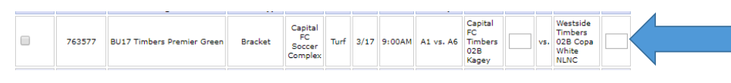
- A new Game Stats window will open. 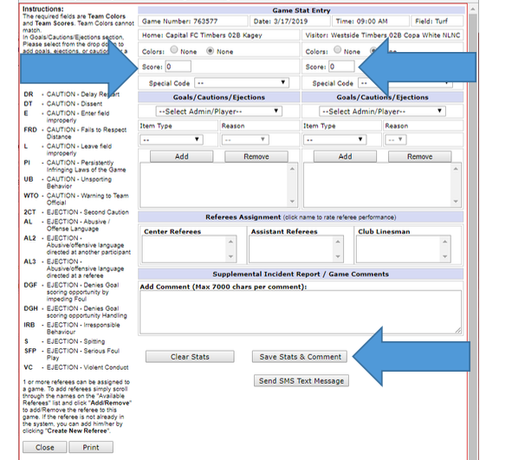
- Enter your score for the match for both the home team and the visiting team. Do NOT enter any cautions or ejections as those will be entered by the league administrator from information gathered from the referee report. When done, click on the Safe Stats & Comments.

NOTE: Please remember that it is extremely important that all scores are entered into the system by both teams after your games. As you enter scores that standings will be updated in the system. When scores are entered by both teams that differ from one another, you will see a red (CS) which means the game has a conflicting score entered. The OYSA staff then looks at the referee report and enters the referee’s reported score as the official score. If scores are not entered by Wednesday, the OYSA staff will enter the score using the referee reported final score.

