Printing Player/Admin Cards (ID Cards)

Team Roster Card Printing
- To print cards, the team needs to be activated. Recreational teams may be activated by the club registrar. Developmental and Competitive teams need to be activated by the State Registrar.
- To print cards from the Team Roster, choose Teams and Team Lookup from the main navigation.
- Select any filters and choose Search.
- From the Search Results, click on the Team Name to view the Team Details.
- Choose the Team Roster tab.
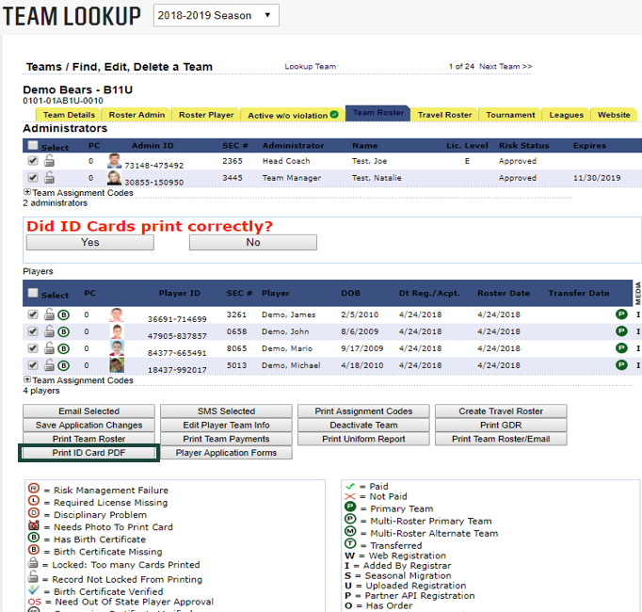
- Choose Print ID Card PDF from below the list of players.
- The Player Card PDF opens in a new tab and displays.
- Choose print by clicking on the printer icon displayed in your Player Cards.
- Once printed, return to the Team Roster page and indicate by choosing YES if your cards printed correctly.
NOTE: Please print your cards in color on 8x11 paper or use Avery Labels 8371. The document is pre-formatted to print with the USYS watermark.

Player Cards Card Printing
- To print player cards from ID Cards, choose Players/Admins and ID Cards from the main navigation.
- Select any filters and choose Search.
- From the Search Results, you will see a list of players or admins meeting the search criteria
- Click the box above the list of players or admins to select all players or all administrators or check only the individuals in which you need to print cards.
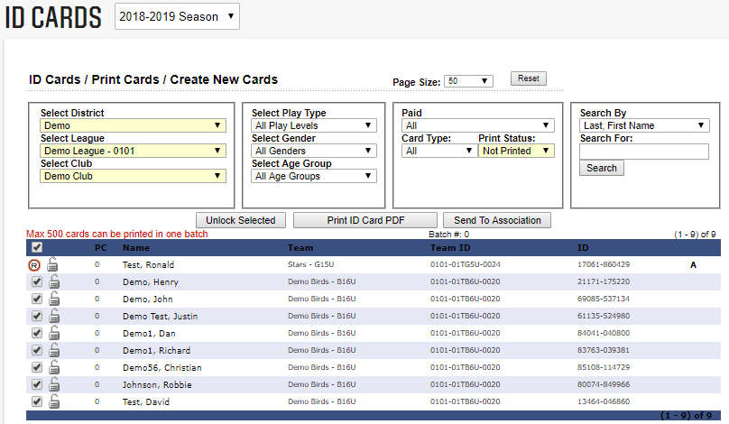
- Choose Print ID Card PDF from below the search drop downs.
- The ID Card PDF opens in a new tab and displays.
- Choose print by clicking on the printer icon displayed in your ID Cards.
- Once printed, return to the ID Cards page and indicate by choosing YES if your cards printed correctly.
NOTE: Turn off the pop-up blocker in your web browser to allow the ID Card PDF to display.
NOTE: Please print your cards on 8x11 blank paper. Do not use USYS cardstock that has the USYS watermark on it. The document is pre-formatted to print with the USYS watermark.

