Club Pass Player
NOTE: Only “Leagues” run by OYSA and the PTTL allow club passing a player. No tournaments or cups use this feature.
The directions below are for Team Admins, Club Registrars can Club Pass players by going to the Team/Tournament Tab and click on edit of the season they want to add player to.
- Log into the Connect Platform and visit your My Account profile.
- Choose the Teams tab.
- Click Tournament & Schedule Apps sub tab.
- Click View Tourn App.
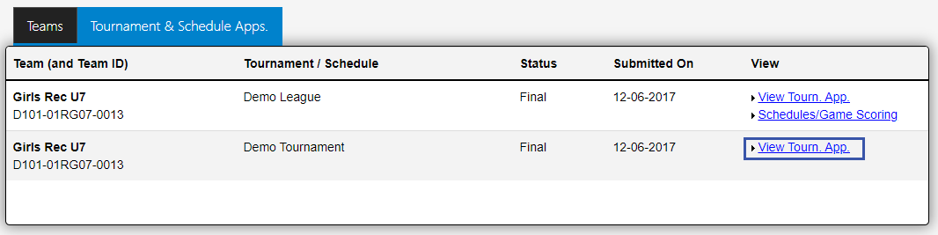
- Click Player Roster.
- Click Add Club Pass Player from below the list of players.
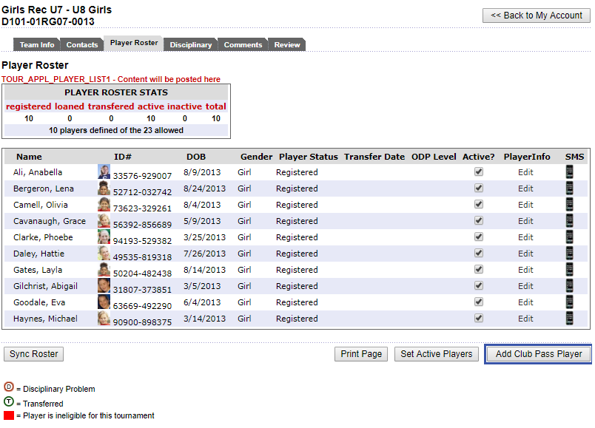
- Search for the player you wish to club pass.
- Click Add to Roster.
NOTE: If the original team roster already has 22 players, then you add club pass players to the roster, you will need to use the “Activate” player box to un-activate a player so all active players will print for the official match roster. I.E. if you have 22 players alphabetically rostered and add 4 club pass players and do not un-activate any players, only the first 22 players alphabetically will print on the official match roster. Once that game is completed, make sure you go back into the team and re-activate the players again for the next game.

