Declaring Multi Teams to Tournament
If a tournament/league play is configured to allow batch applications Registrars can apply a group of teams at once in a batch instead of submitting each time individually. Follow the steps below to declare multiple teams into a tournament/league:
TIP: This process can also be referred to as “batch applying.”
- From the main navigation, hover over Teams and select Declare Multi Teams.
- Select a tournament/ league name from the drop down menu. Click Start Application.
- Select search criteria from the various dropdown menus and choose Search. Only teams that meet the qualifications to play to the respective tournament/ league will appear in the search results.
- Check boxes across from teams you wish to apply. Once selections have been made, click Apply Teams.
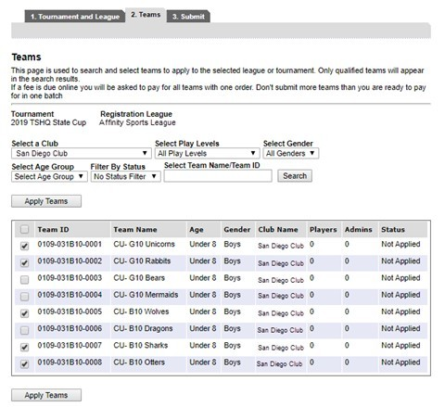
- The Submit screen will display all the teams you have selected on the previous page. If a team was selected in error, click the Remove link across from the team name to eliminate them from this list. Once list of teams has been verified, click Submit Applications.
- Teams have now been submitted into the tournament/ league play. You may click on the order number to pay or submit payment information at a later time by going to the Team’s tournament tab.

