Administrator Username and Password

- Select Admin lookup.
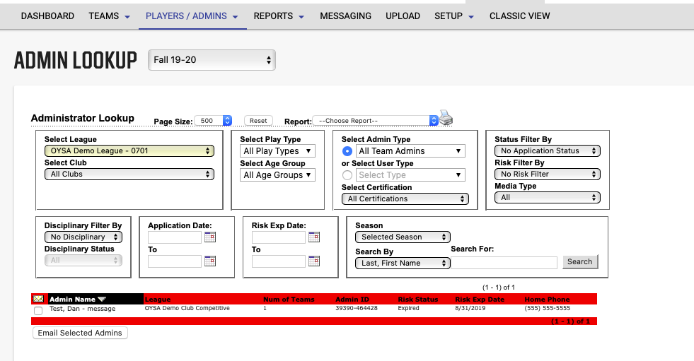
- You can search for Admins under All Seasons or Selected Season.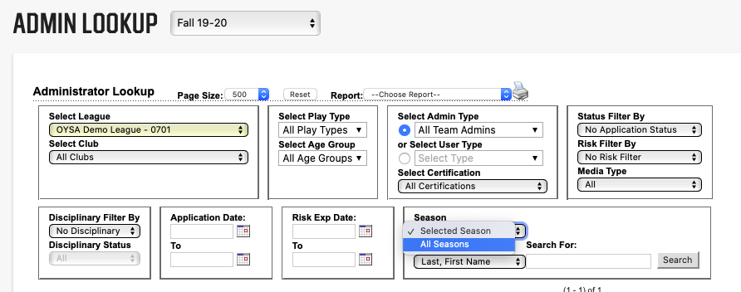

- Search for all team Admins to see all admins in your club. Or type in name of specific Admin to find them.
- Click on specific Admin. Scroll to the bottom of their profile to see current username and password (if they have one). Only the username will appear, the password will be hidden.
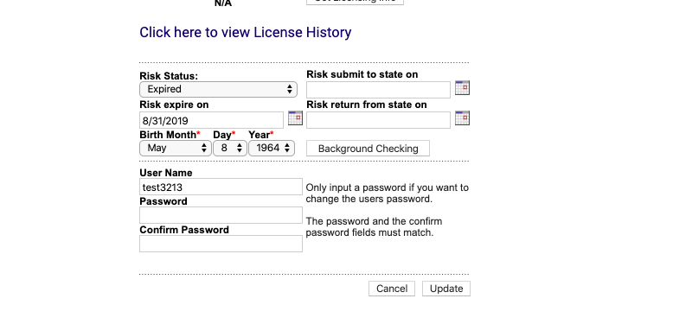
- You can update both the username and password if they do not know them.
- Click update once complete.
- The Admin can login and change their password to one they prefer.
- You can also look up a “parent” and give them login information if they are new to doing a background check.
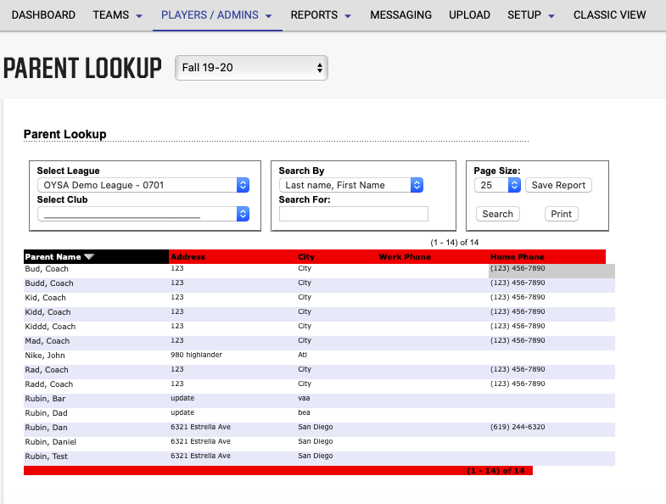
- If the username section is blank, give them a new username and password.
