Registrars Adding and Deleting Player Photos

Registrars have the ability to add/delete player photos to keep them current. It is recommended to check player photos annually to update photos as players get older.

NOTE: Parents and team administrators can upload player photo but cannot delete them.

- Search for player under Player Lookup.
- Once you have player profile open select Click to Upload Profile Photo.
- Upload photo form computer that clearly shows player’s face.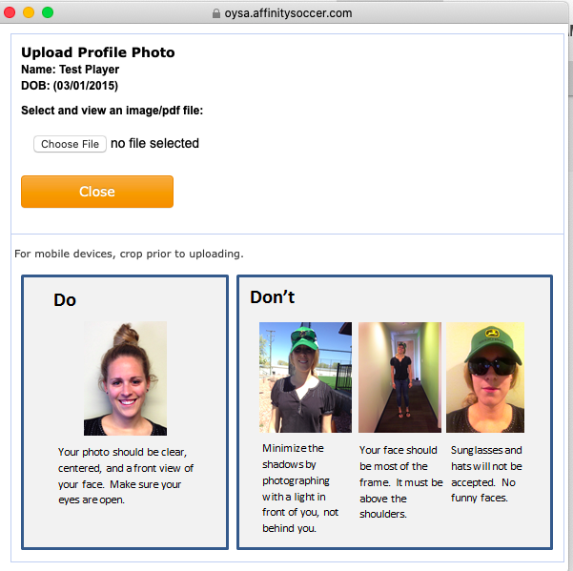
- Crop, resize, and rotate photo as necessary then select Upload Image.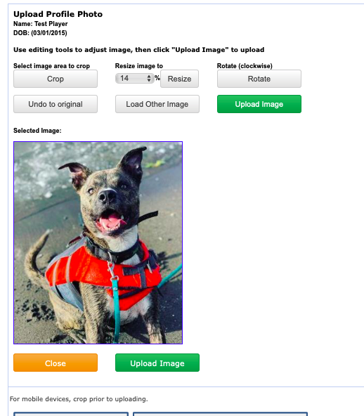
- Registrars can delete photos by clicking on the image and following the steps to delete photos and upload a new one.

Team Administrator Upload Photos

Team administrators including managers can upload player photos for teams they are rostered to and that team is activated. No team administrator can delete photos of players.

Recommendation to Registrars. Delete your photos at the start of the seasonal year and have your team managers load them. This saves you time.

