Player Transfer/Release

Before a player can be released/transferred they must be rostered to a team that has been activated and be going to a team that is activated. All transfers will need the final approval done by OYSA before the player can be placed on their new team. For a player to be transferred onto a developmental/competitive team, they must have a birth document loaded before the transfer can be approved.

- Go to player’s profile that you want to transfer and click on the Transfer tab.
- If you know what team you want to the player transferred to select that option from the Release Type. If you do not know where the player is going, select you are unsure. This means the player will be released into the district pool and OYSA will need to be notified by the club picking up the player.
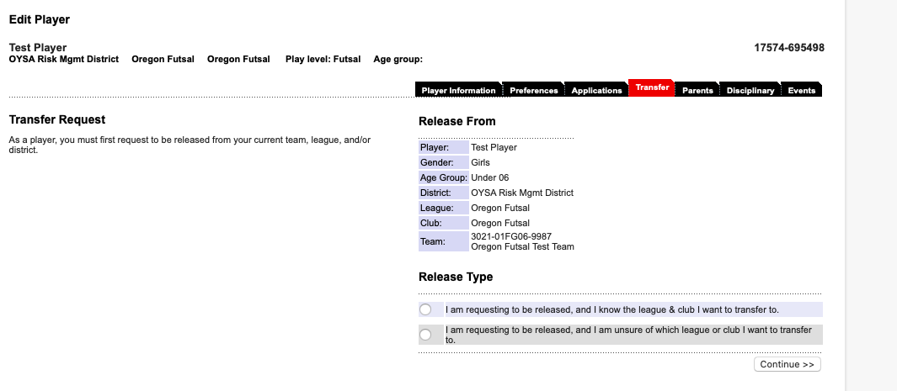
- Fill in all of the information for where the player will be going and the reason you are releasing them. We have included in our full Registrars Manuel a listing of the Districts and Clubs to help you find where the player is going. Then select Submit Transfer.
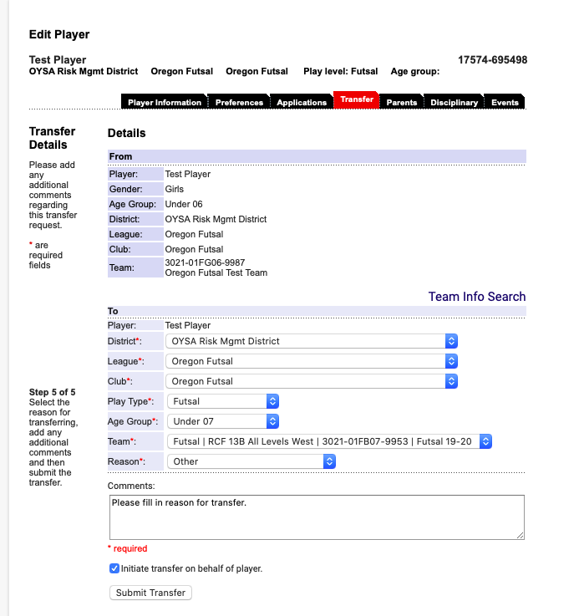
- Click Approve 3 times to completely approve the release of the player. If you are releasing the player to another club then you are done with the transfer. If you are transferring the player to another team in your club go on to approve the receiving of the player. Click Approve 2 times.
- Once you have completed the transfer steps, OYSA will need to do the final approval of the player. OYSA will check to see if a birth document is loaded for a developmental/competitive player before approving the final transfer step. If the player gets rejected by OYSA you will be notified the transfer did not go through.
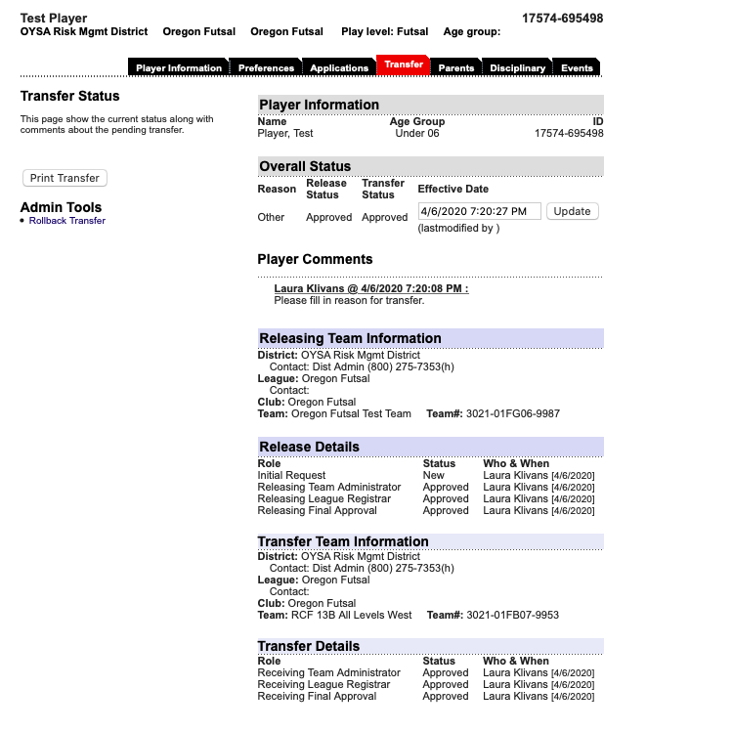

NOTE: If a player has been released to the district pool, you cannot hand-write them onto your team roster. The player needs to officially transferred back to your club to be allowed on one of your teams. Releasing to the district pool means the player is currently sitting outside of your club.

