Sending Teams to OYSA for Activation

All Competitive and Developmental Teams need to be activated by OYSA. Recreational Teams are activated by Club Registrar and do not need to be sent to OYSA for review.

All teams need at least one Head Coach to be approved for activation. Please make sure you’re your teams have enough players on the roster for activation. Do not send in teams with too few of players. Please ensure players have birth docs loaded before you send your teams in for review. Without a birth doc, the player will not be approved. Birth documents need to be the “full page” of the document, clear and easy to read.

- Create team and add minimum number of approved players and coaches.
- Then, go back to the Team Details tab to select “OYSA Competitive Team Activation” for Primary League Registrar. Under that, select “Under Review”. This will checkout your team and notify OYSA that your team is ready for review.
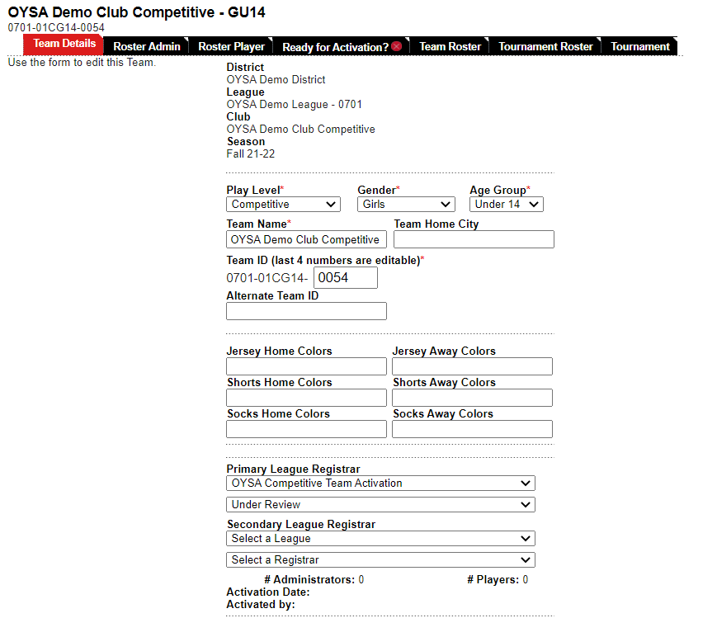
- OYSA will activate your team if all requirements have been met. If OYSA is not able to activate your team, you will be notified.
- Players without approved birth documents will be moved to the bottom of the roster and will need to have an approved birth doc added before they can be officially rostered to the team and a player card printed.

