Rostering Players and Admins to Teams

Rostering Players

1. Choose Teams and Team Lookup from the main navigation.
2. Select any filters and choose Search.
3. From the Search Results, click on the Team Name to view the Team Details.
4. Choose the team in which you wish to roster a player by clicking on the name of the team to display the team details.
5. Choose Roster Player tab. A list of available players will be listed on the screen. You can also search for the Player by typing in their name.
NOTE: Players must be the correct age, have an application with the current seasonal year for your club, and be marked as accepted to be able to be rostered to a team.
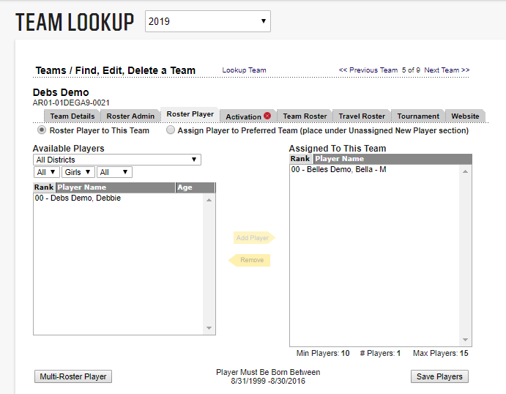
6. Click the name of the player to select and choose Add Player to move the player to the team roster.
7. Choose Save Players to save your work.

Rostering Team Admins/ Coaches

- Choose Teams and Team Lookup from the main navigation.
- Select any filters and choose Search.
- From the Search Results, click on the Team Name to view the Team Details.
- Choose the team in which you wish to roster a coach by clicking on the name of the team to display the team details.
- Choose the Roster Admin tab.
- You will see a list of available coaches to roster to this team on the left side of the screen. You can also input the name of the Coach to locate their profile.
NOTE: Admins/Coaches must have approved background check for current seasonal year with your club and approved SafeSport certificate before they are allowed to be rostered to a team.
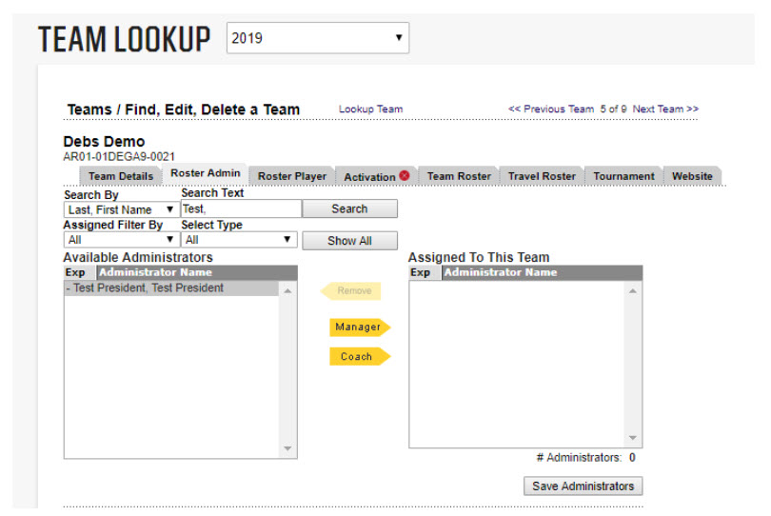
- Click the name of the coach to select and choose their role to move the coach to the team roster.
NOTE: Admin Roles may vary by State/ NGB. Only one team manager on a team, you can mark another admin as an assistant coach.
- Choose Save Administrators to save your work.

NOTE: The typical selection of coaches is Head Coach, Asst Coach, Team Mgr. There can only be 1 Head Coach, 2 or 3 Asst. Coaches and ONLY 1 Team Mgr. per team. Do not put more than 1 Team Mgr. on a team as this will deactivate their team rights.

