Creating Teams (Individual and Multi-Teams)

The Connect Platform offers multiple ways to create teams.

Create Individual Teams

- To create Teams individually, choose Teams and Create from the main navigation.
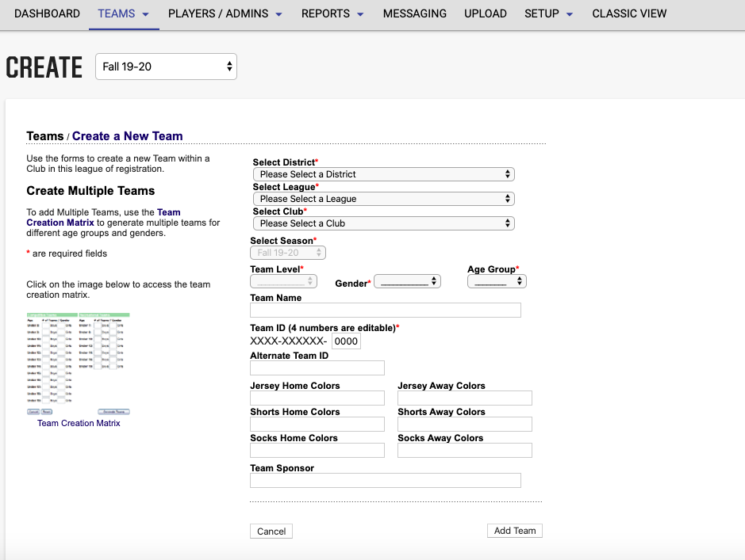
- The District and League will be selected.
- Choose your Club from the dropdown menu.
- Select Team Level, Gender and Age.
- Enter a Team Name. Team name must NOT include any other entity.
- The system will automatically create a Team Number – the last four digits of this number are editable.
- Enter Home and Away Uniform colors.
- Enter the Team Sponsor (if applicable).
- Choose Add Team.

NOTE: Once a team has been created you can create duplicate teams for the same age group.

Creating Multiple Teams

The Connect Platform allows users to create several teams for different age groups at one time.

- To create multiple Teams, choose Teams and Team Creation Matrix from the main navigation.
- The District and League will be selected.
- Choose your Club from the dropdown menu.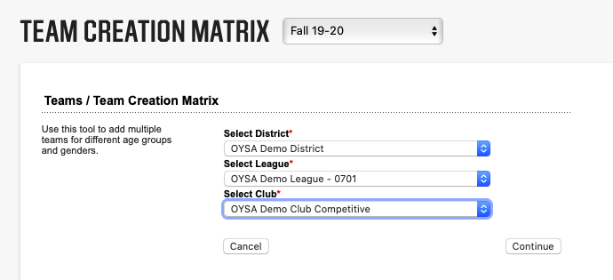
- The Team Creation Matrix will display. Enter the number of teams to be created per age groups and gender for competitive and recreational teams. Click Finish.
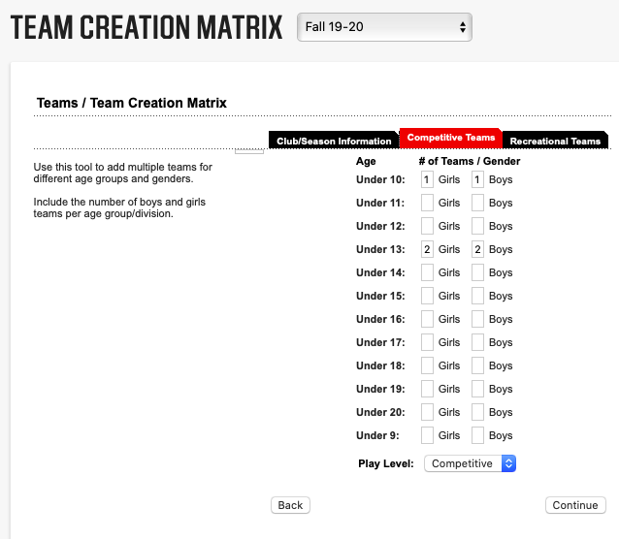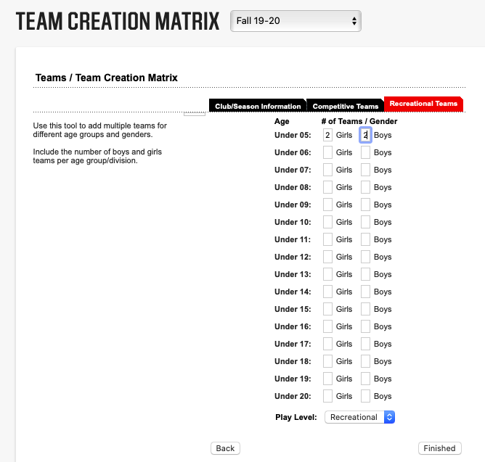
- You will now be able to enter team names for the teams you have just created. Click Rename Teams once complete (you can still change the team name later before it is activated). 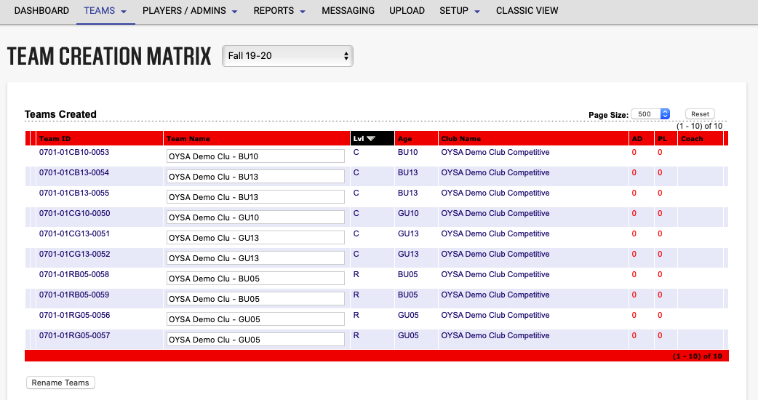
- Now you can go into each team to edit details, add player/coaches, activate team…

NOTE: Please select Boys for Co-Ed teams. Boys cannot play on Girls teams in the Connect Platform.

