Manually Entering Players and Administrators

As a Registrar you can manually add players, families, and admins to the platform.
- Choose Players/Admin and Add Player/Admin from the main navigation.
- Before adding a new player or admin, you will want to verify if this player or admin is already in the system.
- Enter the player/admin first name, last name, and date of birth. Click Find.
- If the user exists, the user profile will display. If the correct user, choose Select beside their name and choose the action you wish to perform (Create Player Application or Create New Coach/Admin Application).
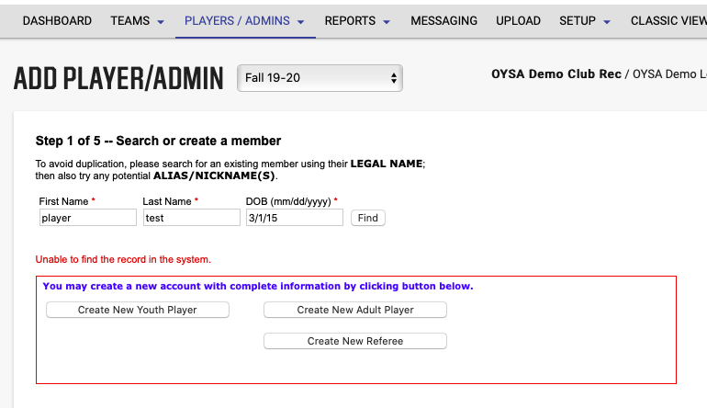
- If no results are found, choose the action you wish to perform (Create New Youth Player, Create New Coach/Admin).
- Enter the user’s information in the form, and for players include information for at least one parent or guardian.
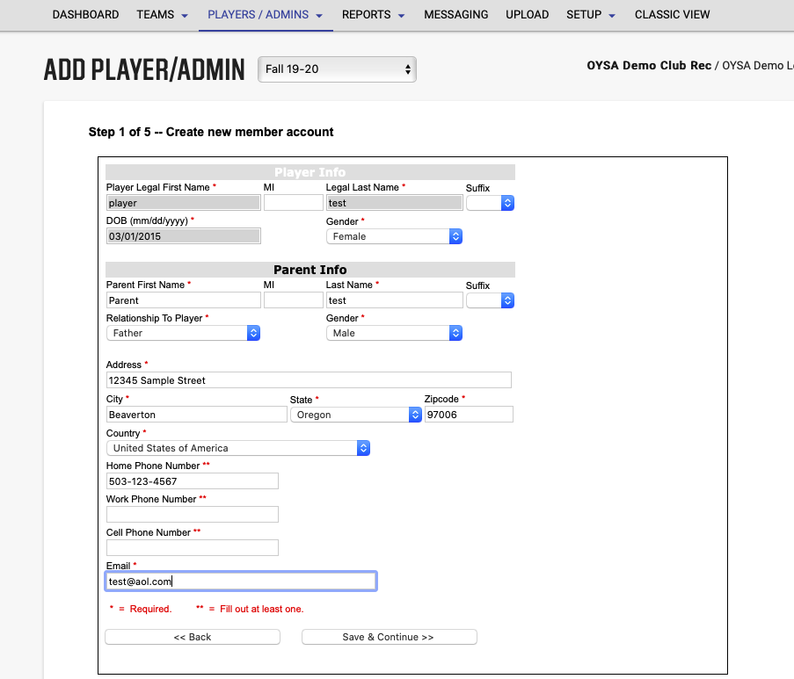
- Choose Continue.
- Select a District, League, Club and Play Level from the drop downs.
- Indicate if a payment was received, if the player is accepted and if the player is age legal. All 3 (payment received, accepted player and age legal player) HAVE to be checked in order to add a player to a team.
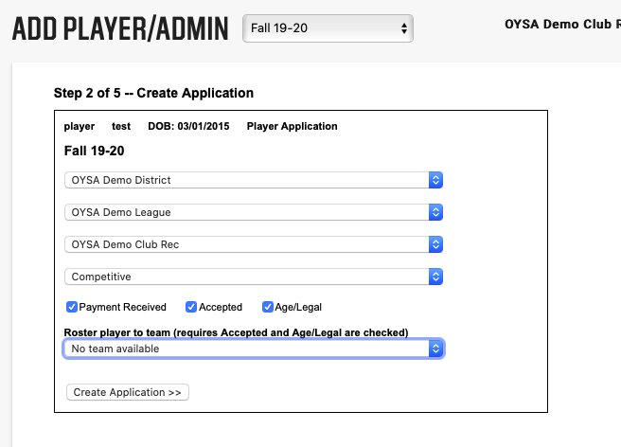
- If applicable, choose the team in which you wish to roster the player and choose Continue.
- Enter the required Player/Admin information. You can also upload player photo and birth document at this point. Choose Save.
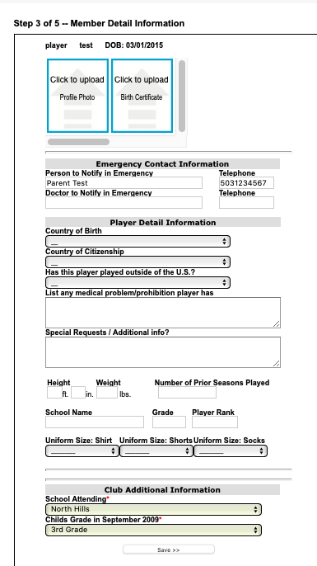

- Agree to the ELA by choosing Agree. If registration is done by registrar, you can bypass the ELA.

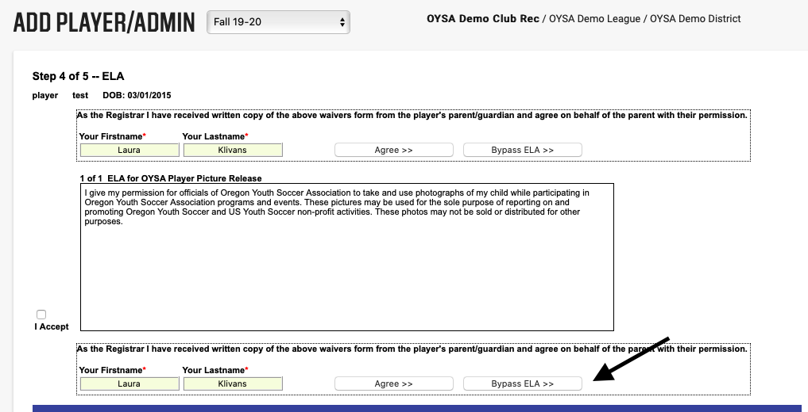
- If you have additional family members to add, choose Add Other Family Member and follow the same process.
- To view the player’s profile choose Detail.
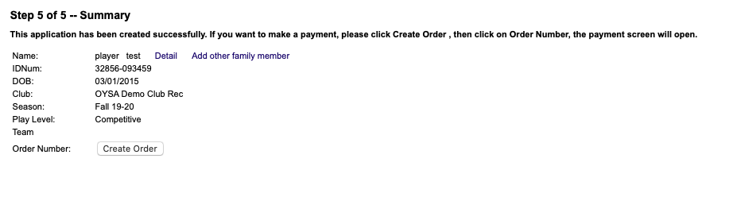
- Choose Add Player/Admin to add additional players or admins.

