Player Lookup

- Click on Player Lookup
- To search for All Applications set your settings to the following (this will list all players in your system):
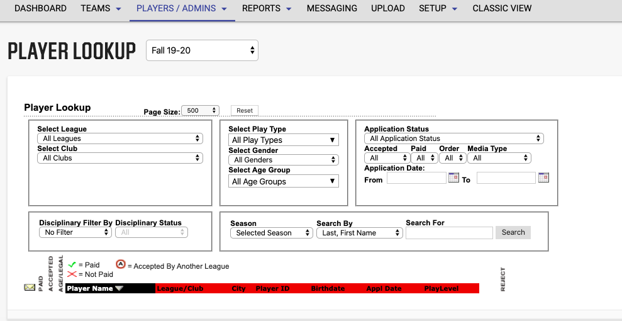
Note: all settings are set to the default. To clear your choices, click on the RESET button in the middle at the top.

To pull a report from here, go to the upper right-hand corner where it says report. This will list any report that is available at these settings. Different pulls will list different reports.
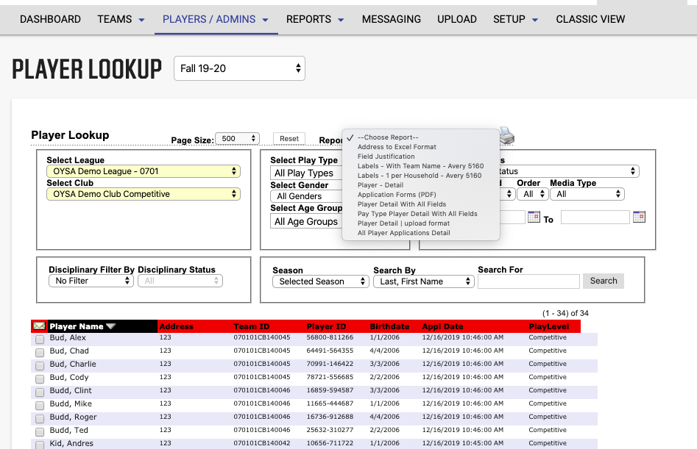

Print Report

- Click on the printer icon to start the export feature. This will pull up a separate window with the report that you have chosen.
- Make sure that you have popup blockers off. You may now export this report to excel.
- Click on the icon to the far left (looks like a disk) the word export will appear when you place your cursor over it.
- Another popup will appear. You will have a list of ways you wish to have the report exported out. Choose the Excel format and it will be easiest to manipulate the data.
- This would be the same format of doing all the reports out of Player Lookup. The one most clubs seem to want is “Player Detail All Fields” for this report you must lookup Pending Application Status. Please have your settings on the following for this report to appear