Player Lookup and Marking Players Accepted and Age/Legal

Looking up Players

- Go to Players/Admin and select Player Lookup
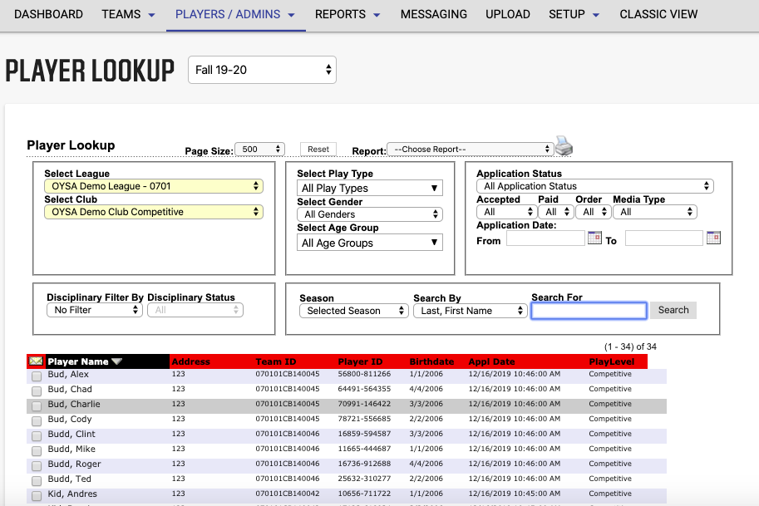
- Select Application status – All Applicants (all players in club), Pending (players not accepted/not on teams yet), Rejected, Cancelled…to see all players in that category.
- Or type in player’s first and last name to search for a specific player.

Marking Players Accepted Age/Legal

- Go to Players/Admin and select Player Lookup
- Set the drop down at Application status to Pending all Applications. If you are just searching for one player, enter their first and last name. Otherwise, just hit search to see all pending players in your club.
- The box for age legal and accepted will appear on the left next to the player’s name. If you are working on one sepcific player, check boxes next to their name and click save. If you are working on all players, selsect the works Accepted and Age/Legal then save (all will updated).
