Setting up a Season
Once the Association has opened the season, the season needs to be configured at the League and Club Level to allow for player and admin registration and the formation of teams. If your League is running multiple seasons, this must be completed per season.
NOTE: This must be done at both the League and League Details levels in the State Platform.
Configure Season at the League Level
1. To configure the season from the League Level, choose Setup and then Config from the main navigation.
2. Choose the Registration tab to display the season screen, which lists all the active seasons created by the Association.
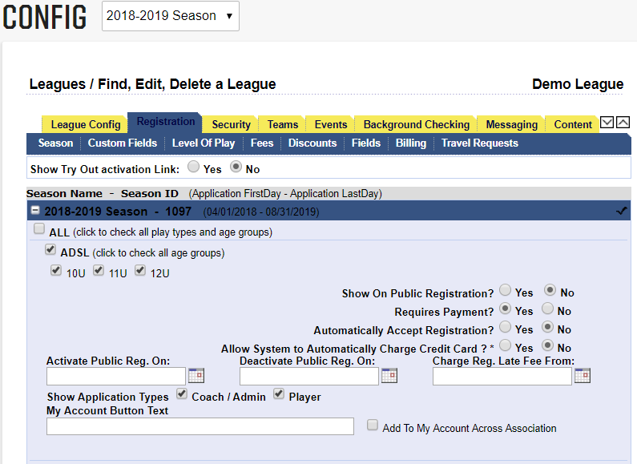
3. Choose the + plus sign next to the season you wish to configure and to open the season configuration options.
4. Check the Play Level and Ages that you allow to register for a specific play type.
5. Choose Yes for “Show on Public Registration”
6. Choose Yes/ No for Requires Payment – if collecting payment, choose yes.
7. Choose No for “Automatically Accept Registration”
8. Choose No for “Allow System to Automatically Charge Credit Card”
9. Leave “Activate Pub Reg. On” blank
10. Leave “Deactivate Pub Reg. On” blank
11. Leave “Charge Reg. Late Fee From” blank
12. Check both “Coach/Admin and Player Application Types”
13. Leave “My Account Button Text” blank
14. Do not check “Add to My Account Across Association”
15. Click Update –when you have completed the above steps for all play types (leagues) and age groups.
NOTE: The age groups in the season grid are player seasonal ages not Team Age Groups. You will need to check any age accepted by your club. Example: U8 is a 7-year-old; however, your club may only have U9 and up Teams but you allow 7-year-olds to be rostered to a U9 team.
Configure Season at the Club Level
1. From the League Level, choose Setup and then Config from the main navigation.
2. Choose the Registration tab to display the season screen, which lists all the active seasons created by the Association.
3. Choose the + plus sign next to the season at the League that you wish to configure.
4. Click the down arrow displayed in the upper right corner of the tabs window to navigate to the corresponding club.
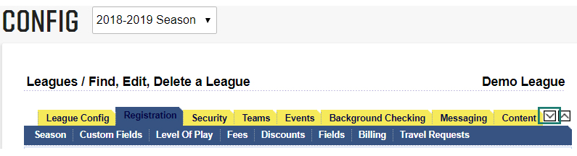
5. The screen title will change to “Clubs/Find, Edit, Delete a Club” and the club name will display.
6. Choose the + plus sign next to the season you wish to configure at the Club Level.
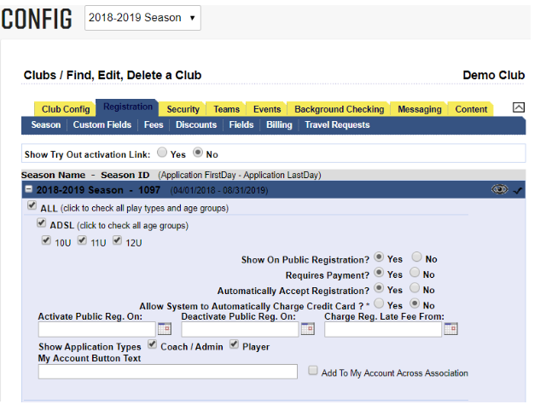
7. The Play Level and Age Groups selected at the League Level will display. If they are not checked , check the play levels and age groups at the club level as well.
8. Choose Yes/ No for Show on Public Registration - if configuring season for Online Registration choose yes. You may wish to wait to choose display on Public Registration until you have finished configuring your season and when ready to begin accepting registrations.
9. Choose Yes/ No for Requires Payment – if collecting payment, choose yes.
10. Choose Yes/No for Automatically Accept Registration – yes, will automatically accept player and admin applications. Note that automatically accepting a player registration, will prompt the billing of this player the following month.
11. Choose Yes/No for “Allow System to Automatically Charge Credit Card.”
12. Enter a date for “Activate Pub Reg. On” bl (optional).
13. Enter a date for “Deactivate Pub Reg. On” blank (optional).
14. Enter a date for “Charge Reg. Late Fee From” blank (optional).
15. Check “Coach/Admin Application Types”
16. Leave “My Account Button Text” blank
17. Do not check “Add to My Account Across Association”
18. Click Update –when you have completed the above steps for all play types (leagues) and age groups.
19. Click the up arrow in the upper right corner of the tab window to go back up to the league level.
NOTE: If configuring a new season, you must log out and log back in for the season to show in your Season drop down.

