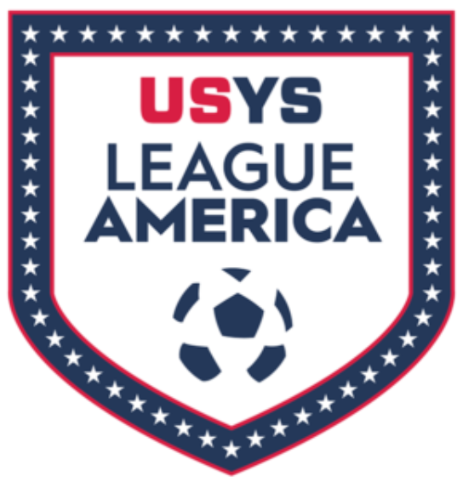
League America Festivals United Cup Roster and Match Form
Club Name: |  |  |  |  |  |  |  |  | Team Name:
Age Group (circle): |  |  | U9 (3rd), U10 (4th), U11 (5th), U12 (6th), U13 (7th), U14 (8th), U15 (9th), U16 (10th), U17 (11th), U18 (12th), U19 Co-Ed |  |  |  |  |  |  |  |  |  | Gender (circle): |  |  | Boys/Girls
Referee: Complete highlighted areas after the game
Team: Complete GAME & TEAM INFORMATION before each game
GAME INFORMATION |  |  |  | TEAM INFORMATION |  |  |  |  |  |  |  | MATCH RESULT & CARD REPORT
Day: |  |  |  | Jersey Color: |  |  |  |  |  |  |  | Home Score:
 |  |  |  | Home or Away: |  |  |  |  |  |  |  | Away Score:
Time:
 |  |  |  | CARD REPORT |  |  |  | # of Yellow Cards: |  |  |  |  |  | # of Red Cards:
Field: |  |  |  | The team on this roster (circle one) WON LOST the match
NAMES MUST BE TYPED – no handwritten names will be allowed
 |  |  |  |  | Jersey # | Participant FULL LEGAL Name |  |  |  |  |  |  |  |  |  |  | Date of Birth
Coach / Manager |  |  |  |  | NA |  |  |  |  |  |  |  |  |  |  |  | ***
Coach / Manager |  |  |  |  | NA |  |  |  |  |  |  |  |  |  |  |  | ***
Coach / Manager |  |  |  |  | NA |  |  |  |  |  |  |  |  |  |  |  | ***
Coach / Manager |  |  |  |  | NA |  |  |  |  |  |  |  |  |  |  |  | ***
Player 1
Player 2
Player 3
Player 4
Player 5
Player 6
Player 7
Player 8
Player 9
Player 10
Player 11
Player 12
Player 13
Player 14 MAX PLAYERS

*** All coaches must have an approved background check and verified SafeSport
All players must be registered with OYSA
Send this roster to Desia Bramel at desia@oregonyouthsoccer.org.
Match Rosters will be provided to the team at check-in
Players may NOT play with or be on the roster for any other teams

